Generate Document (Easy)

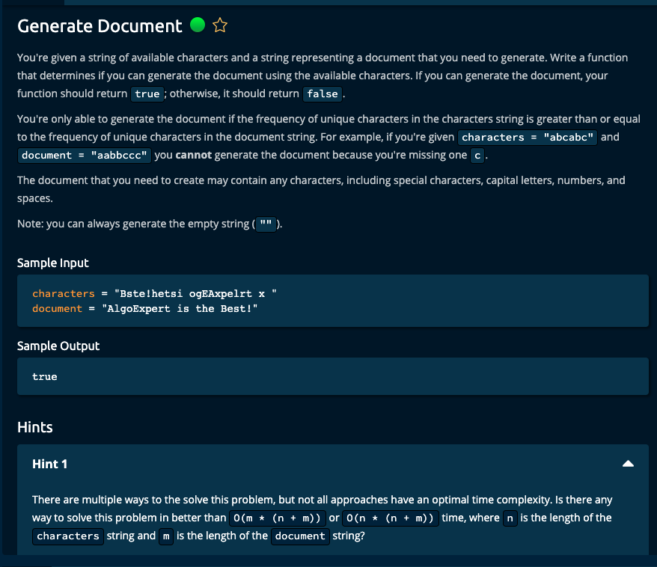

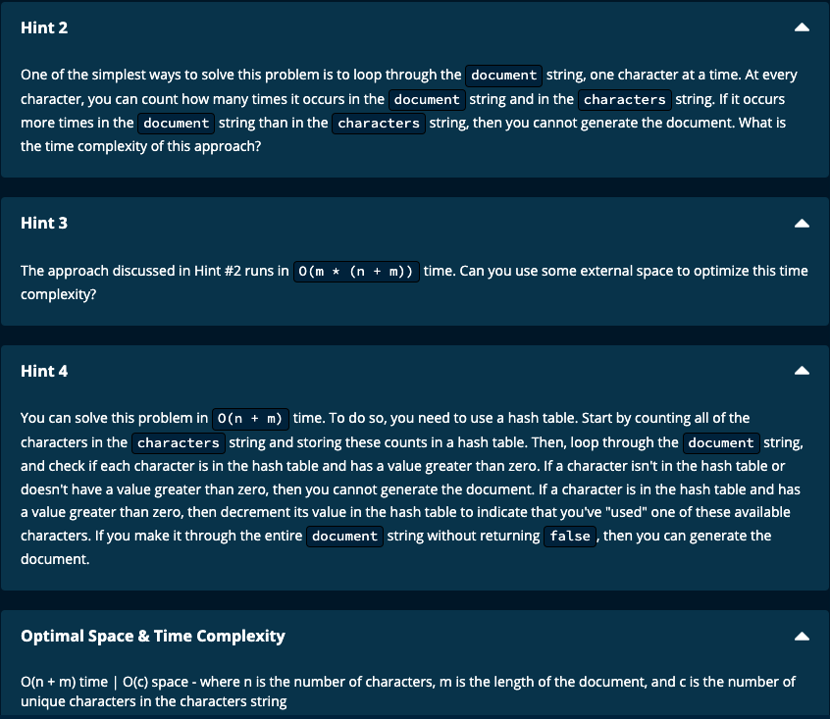

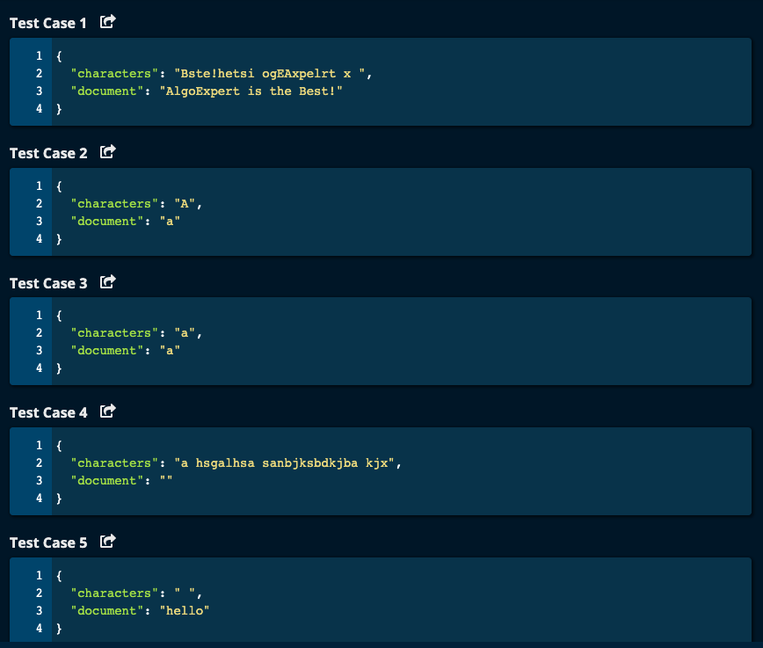

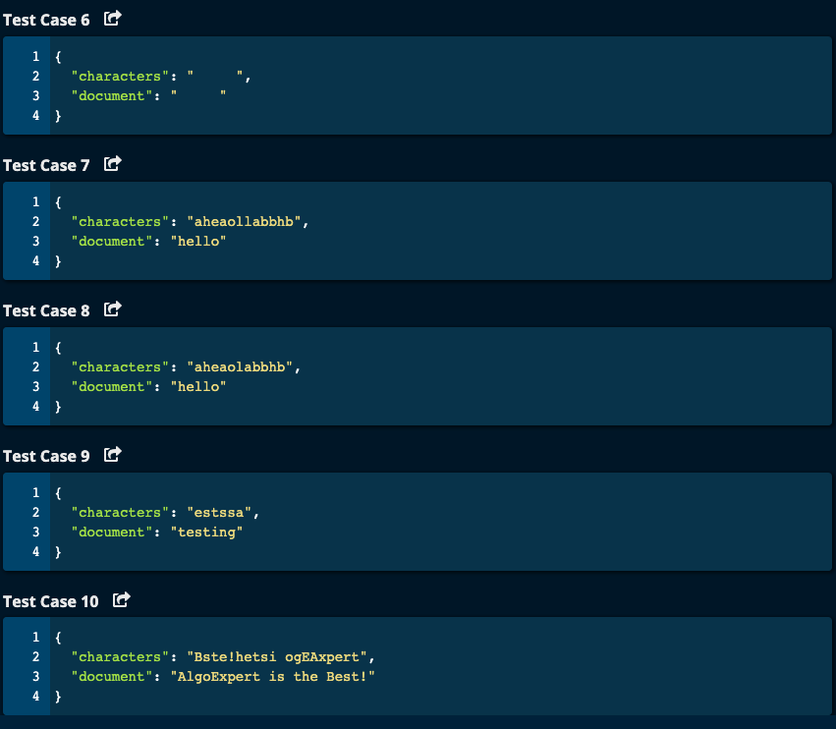

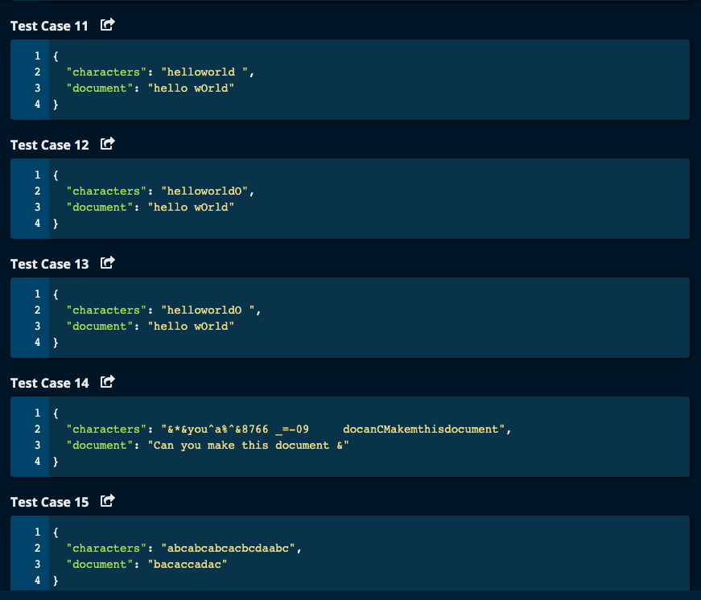

My Solutions:

Solution 1:

JJ Notes:

1. Traverse through characters and put their frequency in a dictionary called charDict.
2. Traverse through the document. If the character is not in charDict, then return False.

If the character is in charDict and has a value of 0, return False. Otherwise the character is in the dictionary and decrement its value by 1/

1. If we are able to traverse the whole document without returning False, then return True in the end.
2. Time Complexity : O(m + n) since we have to traverse the characters and the document

Where m = Number of characters and n = number of letters in the document.

Space Complexity: O(c) where c = number of unique characters.

def generateDocument(characters, document):

charDict = {}

for ch in characters:

if ch in charDict.keys():

charDict[ch] += 1

else:

charDict[ch] = 1

print("charDict = ", charDict)

for ch in document:

if ch not in charDict.keys():

return False

elif ch in charDict.keys() and charDict[ch] == 0:

return False

elif ch in charDict.keys():

charDict[ch] -= 1

return True

----------------------------

Solution 2:

JJ Notes:

1. Call the function getFrequency with characters to get the frequency of letters and return a dictionary called charDict.
2. Call the function getFrequency with document to get the frequency of letters and return a dictionary called docDict.
3. Traverse through the list of docDict keys. If the key is not in charDict keys, or if the value in docDict is greater than the value in charDict, then return False.
4. If you reach the end of the traversal without returning False, then return True.

def generateDocument(characters, document):

charDict = getFrequency(characters)

docDict = getFrequency(document)

for ch in docDict.keys():

if ch not in charDict.keys() or docDict[ch] > charDict[ch]:

return False

return True

def getFrequency(astring):

freqDict = {}

for ch in astring:

if ch in freqDict:

freqDict[ch] += 1

else:

freqDict[ch] = 1

return freqDict

Algoexpert Solutions:  
  
Solution 1:

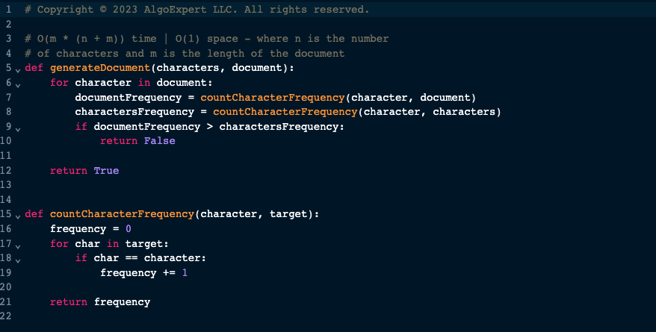

Solution 2:

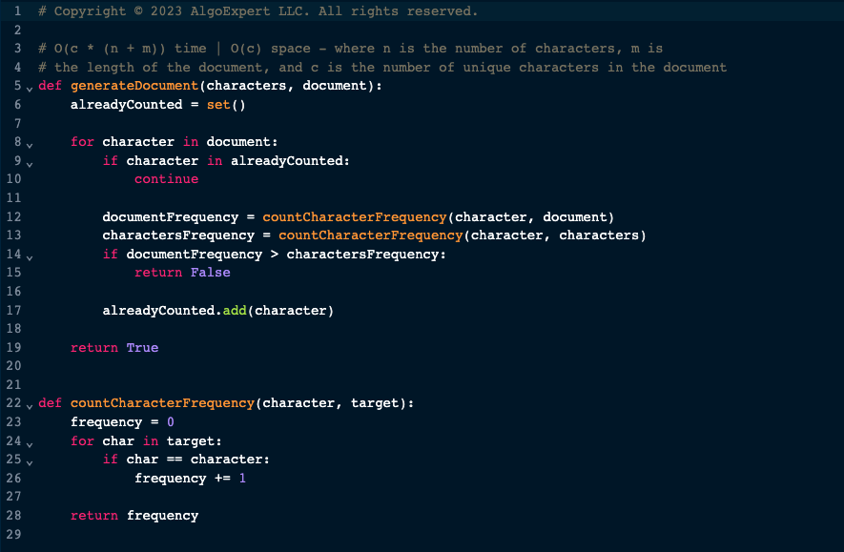

Solution 3:

